**Title: Principles of Management**

|  |  |
| --- | --- |
| **MG 101-065** | **Fall 2024** |
| Wellesley 301 Tuesdays | September 4– December 19, 2024 |
| 3 credits |

**Faculty**

|  |  |
| --- | --- |
| **John P. Killeen MSF** | **Student Hours:**  By appointment |
| [jkilleen@massbay.edu](mailto:jkilleen@massbay.edu) | Accessible via e-mail or Voice |
|  |
| Cell: 781-249-6851 |

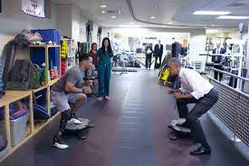

LET'S TALK!!! Please feel free to reach out to me to talk about anything that you would like. Worried about your grades in the course? Let's talk about it. Not sure if you should withdraw from the course? Let's talk about it. Unclear about what an assignment is looking for? Let's talk about it. Interested in finding out more about academic programs or career paths? Let's talk about it. Communication can provide clarity, can help alleviate anxiety, and can help answer questions...so LET'S TALK!

**Required Course Materials**

|  |  |
| --- | --- |
| **Title** | **Relevant Information** |
| Management | OpenStax Textbook PDF <https://openstax.org/details/books/principles-management> |
| Course link: <https://blackboard.massbay.edu/ultra/courses/_67393_1/outline> |  |

**Course Description (from catalogue):**

Integrates traditional and behavioral approaches to management. Managerial functions of planning, organizing, staffing, leading and controlling. Decision-making, leadership, communications, coordination, delegation and authority-responsibility relationships. Appreciation of the technical and conceptual aspects of organizational thinking. Selected case studios and contemporary examples are used to illustrate the application of management principles.

|  |
| --- |
| **Student Learning Outcomes** |
| 1. Describe the theories, principles and practices of management. |
| 1. Apply the management functions of planning, organizing, directing and controlling and the technical, interpersonal, teambuilding, leadership and decision-making skills needed by managers to the modern organization. |
| 1. Analyze how change and innovation could help the organization maintain its competitive edge and how the domestic and global environment relates to business strategy. |
| 1. Critique the environmental, social, ethical and community obligations and responsibilities that is required by organizations. |
| 1. Review and assess the information technology that enables organizations to provide more effective products and services and to be competitive. |
| 1. Propose managerial solutions to common management problems in the area of human resources management, project management, strategy development, and fostering innovation. |
| 1. Demonstrate an awareness of appropriate ethical behavior as it relates to a company’s code of business conduct/ethics. |
| 1. Identify and construct communications strategies that deal with barriers to communications, modern communications technologies, listening and meeting skills, non-verbal communications and the grapevine. |

|  |
| --- |
| **FYS Learning Outcome** |
| 1. Students will demonstrate the ability to utilize the wealth of academic, cultural, and social resources at MassBay for self-advocacy and personal empowerment. |

**Course Requirements, Policies and Grading**

In order to successfully pass the course, students must be prepared to:

1. **Attendance Policy:** Attend all scheduled classes and/or participate online as required. School attendance policy can be found in the MassBay student handbook [https://www.massbay.edu/handbook](https://www.massbay.edu/handbook%20%20%20%20%20%20%20%20%20%20%20%20%20%20%20%20%20%20%20)
2. If an online course, refer to the DE-2 form in BlackBoard. This document contains the interactions that students are required to engage in to successfully complete the course.
3. Follow the academic integrity and plagiarism policies that can be found in the student handbook <https://www.massbay.edu/handbook>. For additional information on plagiarism, visit <https://poorvucenter.yale.edu/writing/using-sources/understanding-and-avoiding-plagiarism>
4. Maintain respectful and professional standards in all communication, including emails and course discussions, in-person and online.

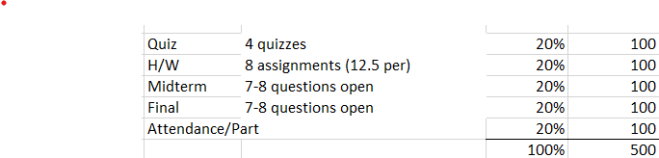

**Teaching Procedures and Semester Overview**

Instructional methods may include class and Blackboard discussion, case studies, lecture and readings, media (internet, videos, clicker questions and online components), discussions, individual and group problem solving, projects, site visits, as applicable.

Throughout the semester, you can expect…

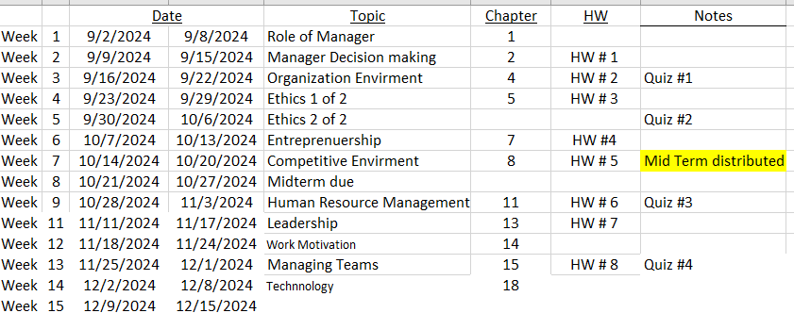

**Artificial Intelligence**

One of the many “benefits” of this AI phenomenon is to automate and assist we humans with information. Sometimes referred to as an advanced Search Engine. As amazing and transformative the development and access to us is, in our class I would state that we are not to utilize the service when writing responses to questions on Mid-term and Finals. The reasoning is that a goal in the class is that *YOU* show and demonstrate your mastery of the subject.

**MassBay Institutional Accessibility Services Syllabus Statement**

The Accessibility Services Center works closely with the administration, faculty, and students to identify and remove any physical, programmatic, or attitudinal barriers that might discourage, frustrate or deny the full participation and integration of students with disabilities in the College's complete range of programs, activities, and courses of study.

MassBay provides equal access for each student who self-discloses a disability and requests accommodations through the Accessibility Services Center for learning, testing, and other areas of need.

Students can:

■ Make an appointment with a disability specialist;

■ Provide appropriate documentation of the disability; and

■ Request accommodations that will facilitate academic success.

Disability Specialists collaborate with faculty, providing guidance to students in the areas of:

■ Universally Accessible Classrooms;

■ Self-advocacy;

■ Applying learning strategies for academic success;

■ Advising during course enrollment; and

■ Finding mentoring and support opportunities.

Accessibility Services Center

Room 216, Wellesley Hills Campus -- 781-239-2234

Room 306, Framingham Campus -- 508-270-4267

# accessibilityresources@massbay.edu

**Campus Resources – see Appendix A for detailed information on campus resources and policies**

**Syllabus Appendix A – Campus Resources**

# **Helpdesk Support for MassBay Systems**

[helpdesk.post.massbay.edu/home](http://helpdesk.post.massbay.edu/home)

* Campus Logon / Password
* Blackboard Learn
* Bay Navigator
* Email

Wellesley Hills Campus: Room 242F (rear of main lab) / Framingham: Room 305 (library/lab)   
Email [helpdesk@massbay.edu](mailto:helpdesk@massbay.edu) or call 781-239-2440 (24/7/365)

**The Office of Online Learning** is available to assist students with information and best practices for taking their online and hybrid courses!

* what to expect in an online course;
* common technologies used;
* time management and where to go for additional help.

Once you log into Blackboard, visit [MassBay Online](https://blackboard.massbay.edu/webapps/portal/execute/tabs/tabAction?tab_tab_group_id=_86_1) to access resources. For more information on how to be a successful online learner, feel free to schedule a consultation with Online Learning by emailing [bsibuma@massbay.edu](mailto:bsibuma@massbay.edu) or [clabarbera@massbay.edu](mailto:clabarbera@massbay.edu).

**Library Resources**

MassBay has a library collection of more than 30,000 volumes and a host of electronic resources including e-books, streaming videos and bibliographic databases. The College is a member of the Higher Education Libraries of Massachusetts (HELM) that provides access to the collections of 7 college libraries across the state. Interlibrary loan and delivery services are available to students and faculty. Librarians are located on both campuses to assist students with research, using the catalog, and accessing online databases.

**Academic Achievement Center (AAC)**

The Academic Achievement Center (AAC) employs professional learning specialists and peer tutors across subjects. They help students with reading and study skills, writing for any class, and all levels of math and science. The AAC welcomes both walk-ins and appointments and is open Monday-Friday on both campuses. Online tutoring is also available. The AAC is located in Framingham on the third floor, inside of the Library, and in Wellesley Hills on the second floor, next to the Library. For more information or to make an appointment, visit [www.massbay.edu/aac.](http://www.massbay.edu/aac) Email [aac@massbay.edu.](mailto:aac@massbay.edu) or call 508-270-4213 (Framingham) or 781-239-2632 (Wellesley Hills). All services are free.

**Accessibility Services**

MassBay provides equal access for each student who self-discloses a disability and requests accommodations for learning, testing, and other areas of need. To meet with a disability specialist to discuss your learning needs. Please call or stop by to make an appointment. Please note that we encourage students who would like academic accommodation in the course to meet with a disability specialist as soon as possible to complete the necessary Learning and Testing Accommodation Form required by the college for all academic accommodations. Accessibility Services Center is located in Framingham Room 306 (next to the Library) and in Wellesley Hills Room 216 (in the AAC). Framingham: 508-270- 4267. Wellesley Hills: 781-239-2234.

**Testing Services**

The AAC offers make-up exam services to students who have a legitimate reason for taking their exam outside of class. All exams must be dropped off and picked up by the professor. Exams are by appointment only, and it is the student's responsibility to make an appointment. Students will need a picture ID to take the exam in the AAC. Please call the AAC directly for more information: Framingham: 508-270-4213, Wellesley Hills: 781-239-2632.

**Counseling Services**

Taking care of oneself amidst the pressures of school, family, work, and relationships can often be part of the challenge of being a college student. Learning how to better adapt and cope with these stressors can improve the quality of your life and enhance your success at MassBay. Counseling is the process during which you work with a professionally trained, licensed counselor in becoming a healthier human being in all aspects of life: Emotional, Intellectual, Physical, and Spiritual.

When you make your first appointment, you will simply be asked to provide us with your contact information and best way to reach you. There is no need to disclose why you want to see a counselor when you make an appointment. Counseling Services at the Office of Student Development:

Wellesley Campus, Room 130 - Call 781-239-3142

Framingham Campus, Room 100 - Call 781-239-3142

**The Advising Center**

The Advising Center is committed to assisting students in the development of meaningful academic plans that are compatible with their professional and life goals. Services provided by the Advising Center include:

* Assistance with course registration, adding and dropping classes and course withdrawals
* Transfer Credit Evaluation
* Information on Challenge Exams
* Information on Competency Exams {AP, CLEP, UExcel, DANTES)
* Change of Advisor
* Change of Major
* MassTransfer and Transfer Counseling
* Permission to take courses at other institutions
* Graduation Reviews
* Referrals to other campus resources

All registered students are assigned an academic advisor. The name and contact information for one's advisor is available on the Student Center page of Bay Navigator. Advisor assignments are generally made during the fourth week of the fall and spring semesters.

Our locations are room 113 in Wellesley Hills and the first floor Enrollment Center in Framingham.

**Student Well Being**

MassBay faculty and staff believe it is important to support the physical and emotional well-being of our students. Any student who has difficulty affording groceries or accessing sufficient food to eat every day, or who lacks a safe and stable place to live, and recognizes that it is affecting their performance in the course, is urged to contact the Student Development Office at 782-239-2753 or [studentdevelopment@massbay.edu](mailto:studentdevelopment@massbay.edu) for resources and support. For all available resources, see: <https://www.massbay.edu/studeve>.

**Campus Resources and Policies**

*Note for instructors: you may wish to add this section to your on-line syllabi posted in Blackboard and/or include these descriptions in the syllabus itself.*

Visit the links below for more information on:

* [Academic Achievement Center (AAC)](https://www.massbay.edu/academics/aac)
* [Accessibility Services Center](https://www.massbay.edu/facilities/accessibility)
* [Library](http://www.massbay.edu/library/)

* [Testing Services](https://www.massbay.edu/placement-testing-faqs)
* [Smart Thinking](https://www.massbay.edu/academics/aac/tutor/online)
* [Academic Calendar](https://www.massbay.edu/academics/academic-calendar)
* Computer Use Policy
* [Student Handbook](https://www.massbay.edu/handbook)
* [College Catalog](http://massbay.catalog.acalog.com/)